

**EXTRUDED LINEAR BAFFLE CEILING SYSTEM**

**DATASHEET**

Technical Info:

Product : Aluminium Linear Suspended Ceiling System

Sizes : 20x100mm, lengths : according to shop drawing

Suspension System : Hook-on system made of main runner Z (20x40x20x1mm), main runner L (25x25x1mm), galvanised steel, with slots and holes

Specification:  
c/c: 100mm center to center distance.

Drawing 1: Aluminium Linear Ceiling Plan

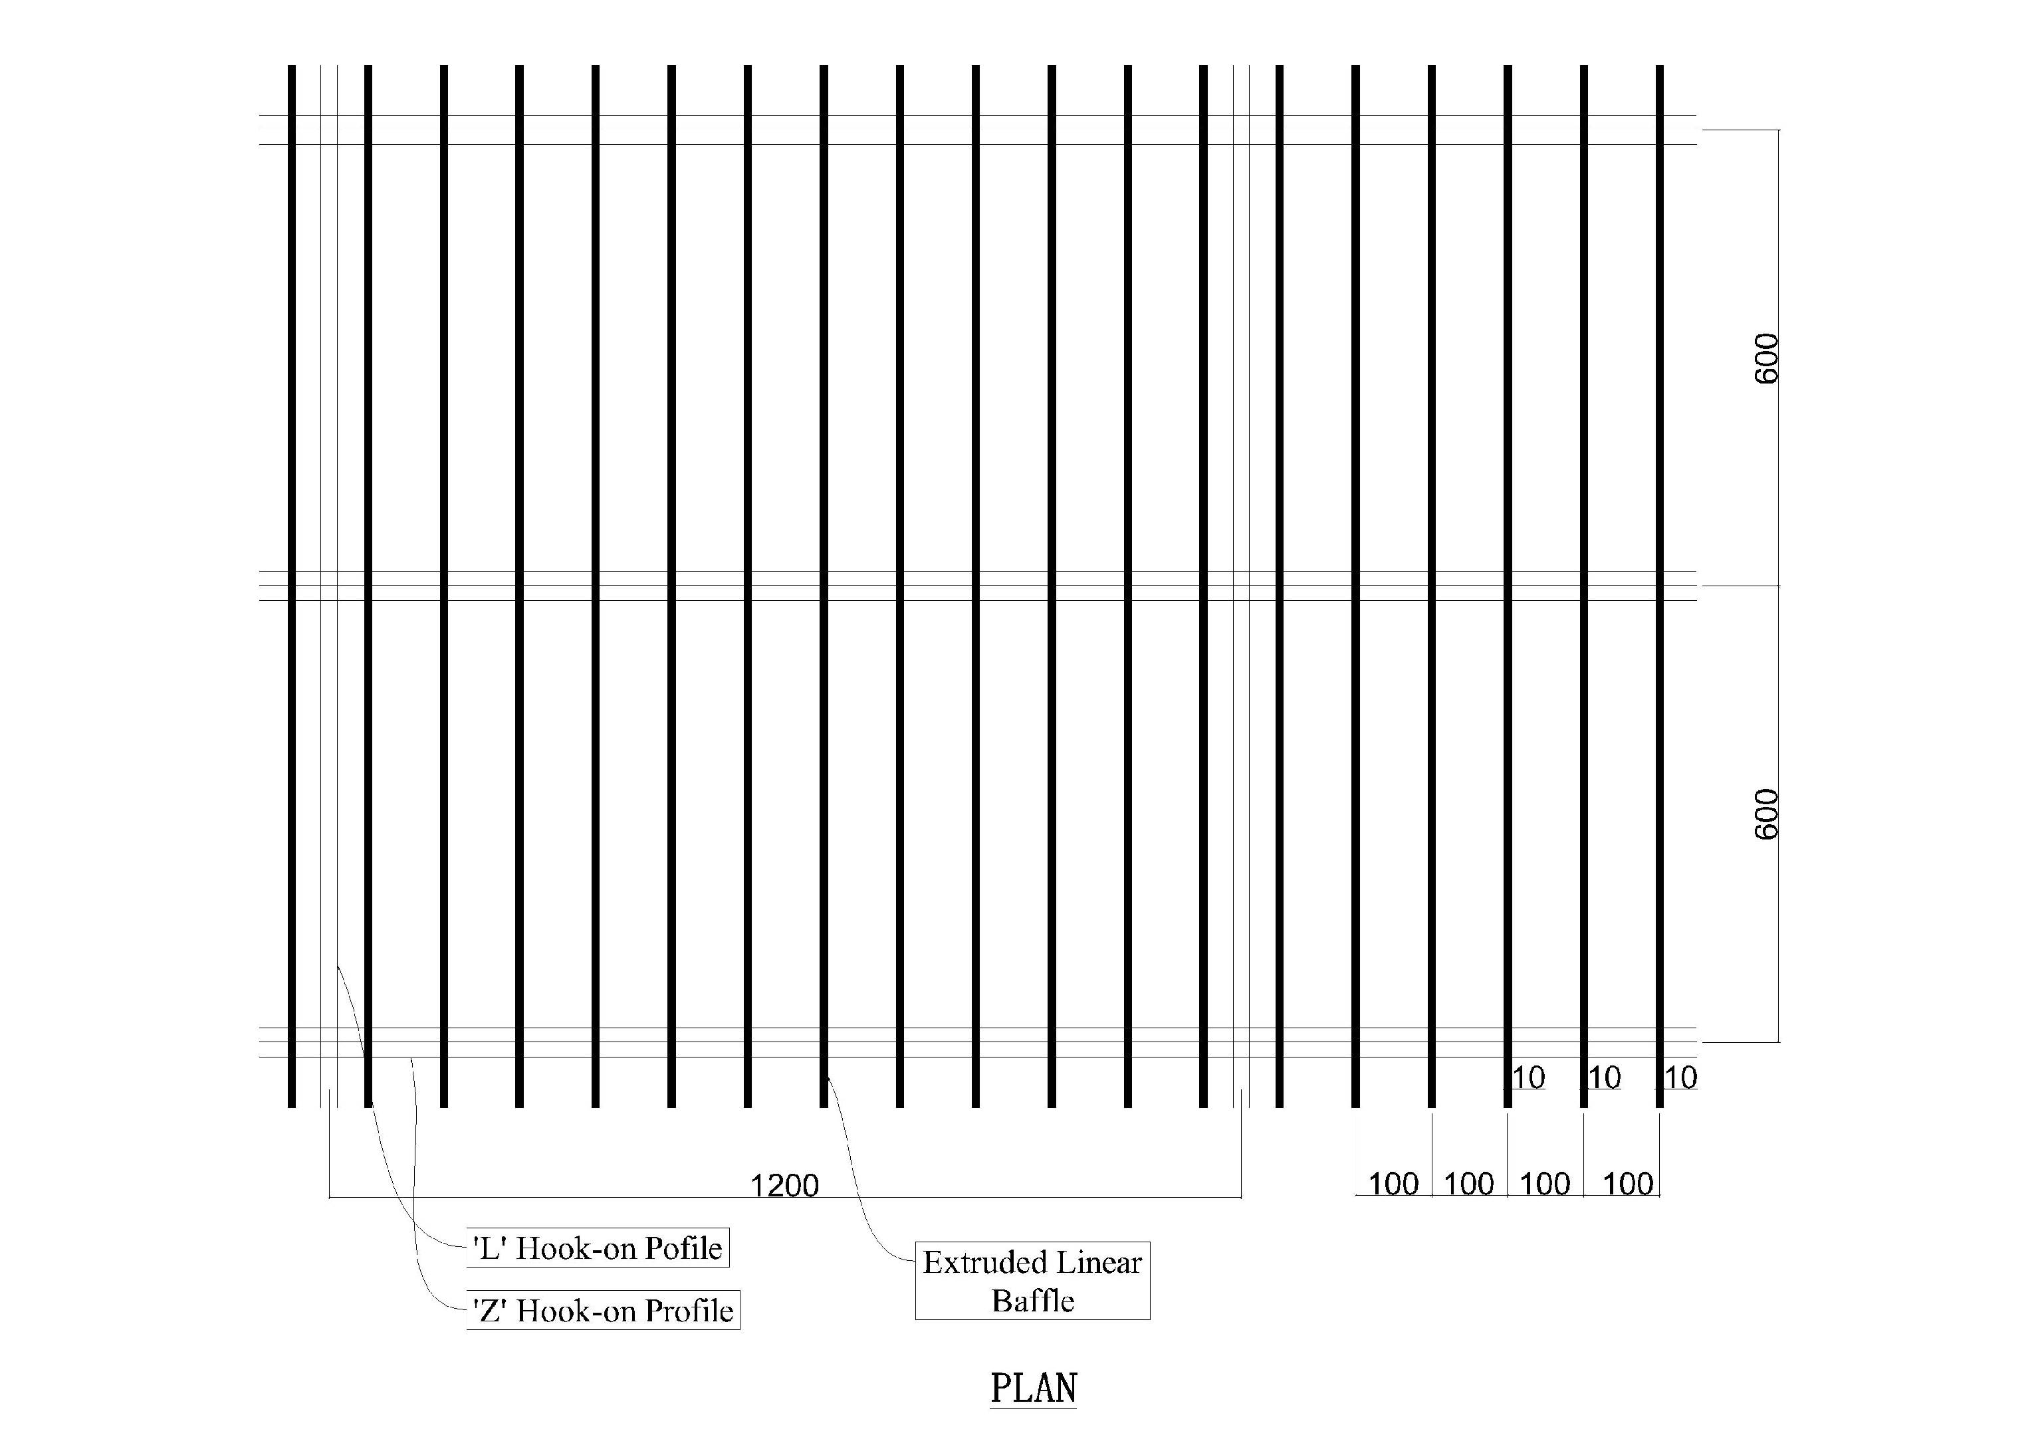

Drawing 2: Aluminium Linear Ceiling Section A

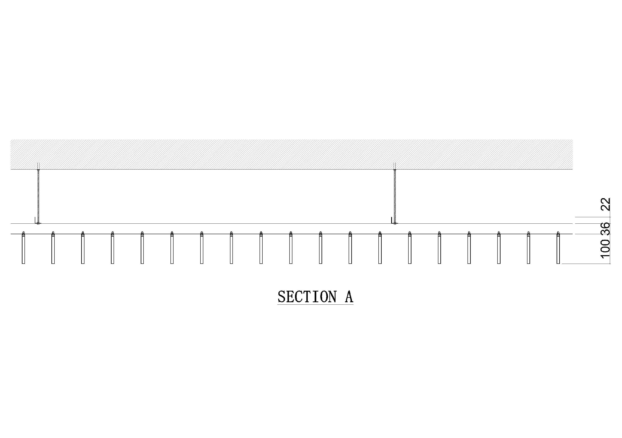

Drawing 3: Aluminium Linear Ceiling Section B

