

DECKON PREMIUM METAL CEILINGS
PANEL F SYSTEM
DATASHEET

Technical Info:

Product : aluminium or galvanised steel
Module : 200 F
Thickness : 0.50 - 0.70 mm
Surface : electrostatic powder coated
Perforation : none or ∅1.8-2.5mm hole diameter
Suspension sys : main carrier profile
Fire Resistance : class A as steel
Color : RAL 9016 - standard white or desired RAL colors

Specification:
The linear closed – locked system. Panels are overlapped and mounted onto the main runner or can be screwed to the structure behind. Suitable for exterior applications. Resistant to the wind load. Ideal for use under the canopies.
VISUAL
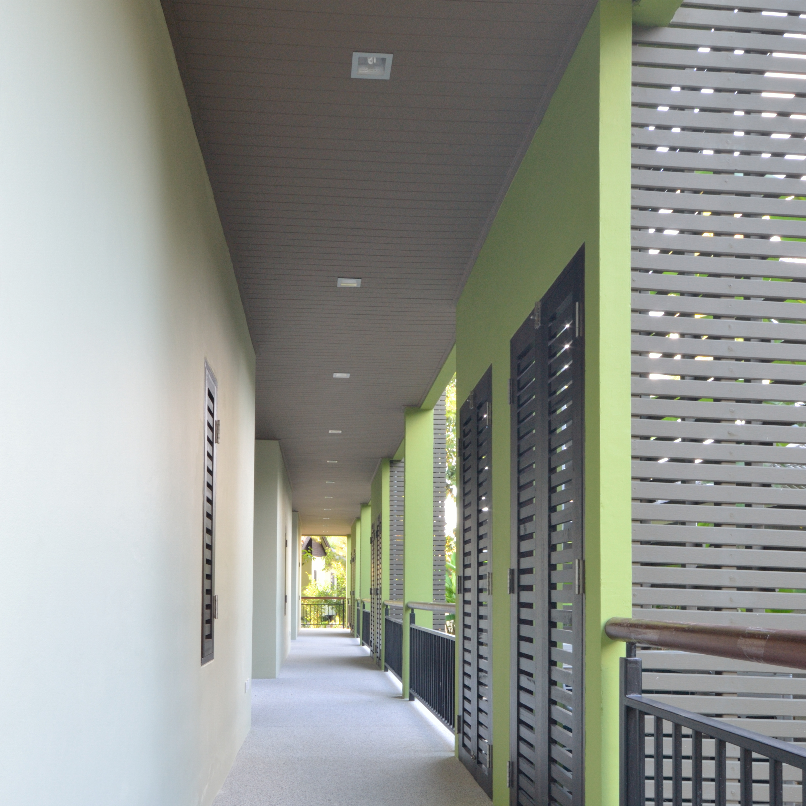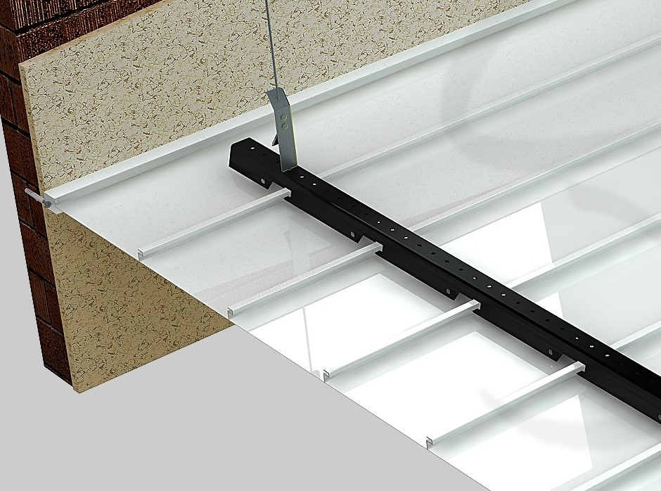

TECHNICAL DRAWING
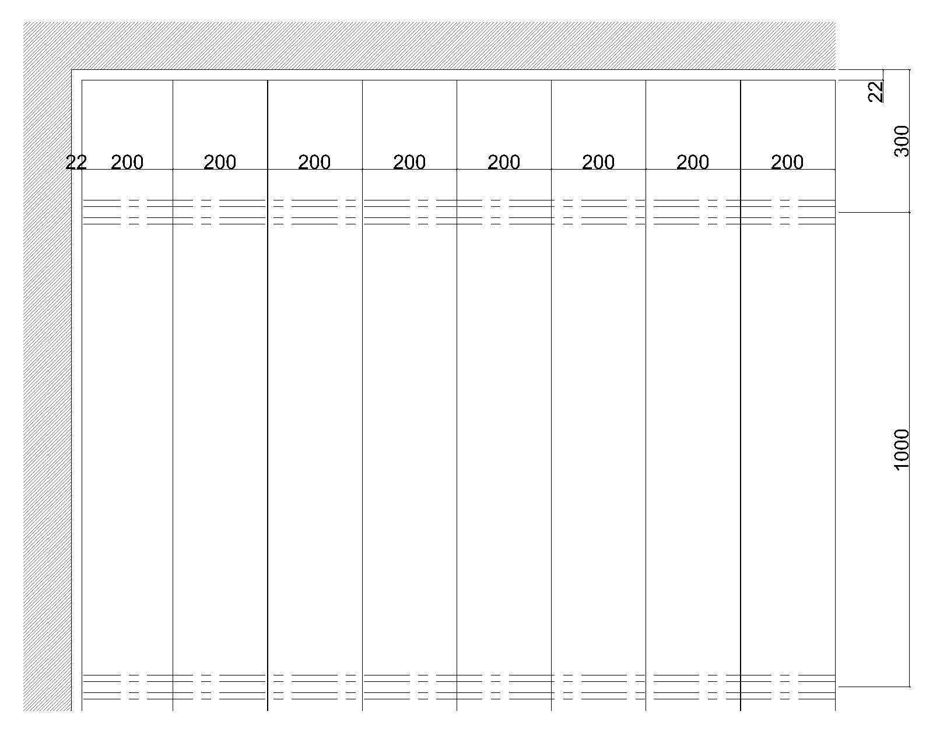
PLAN
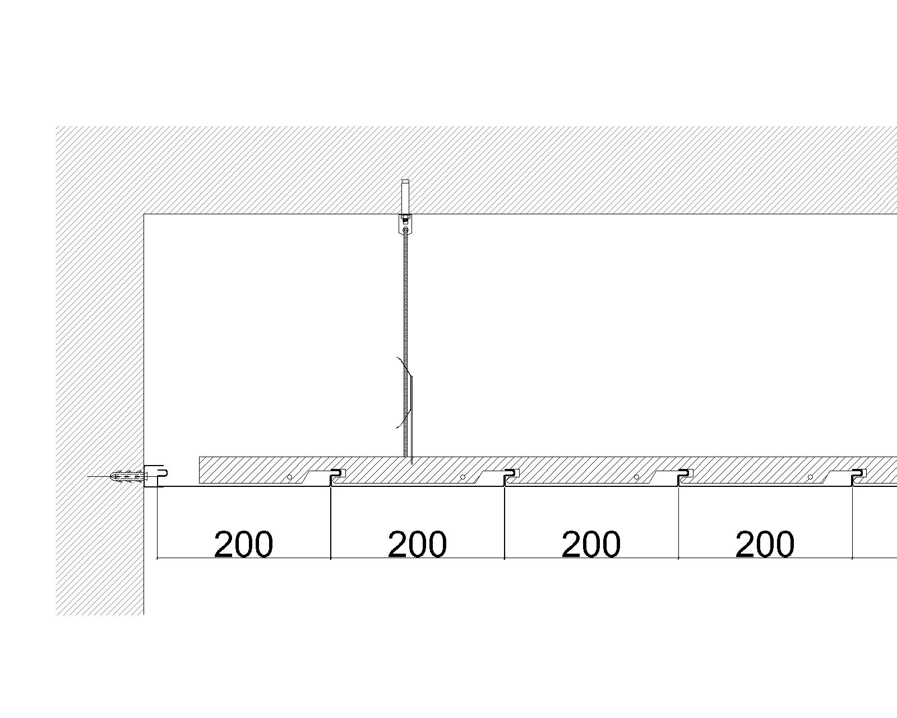
SECTION A
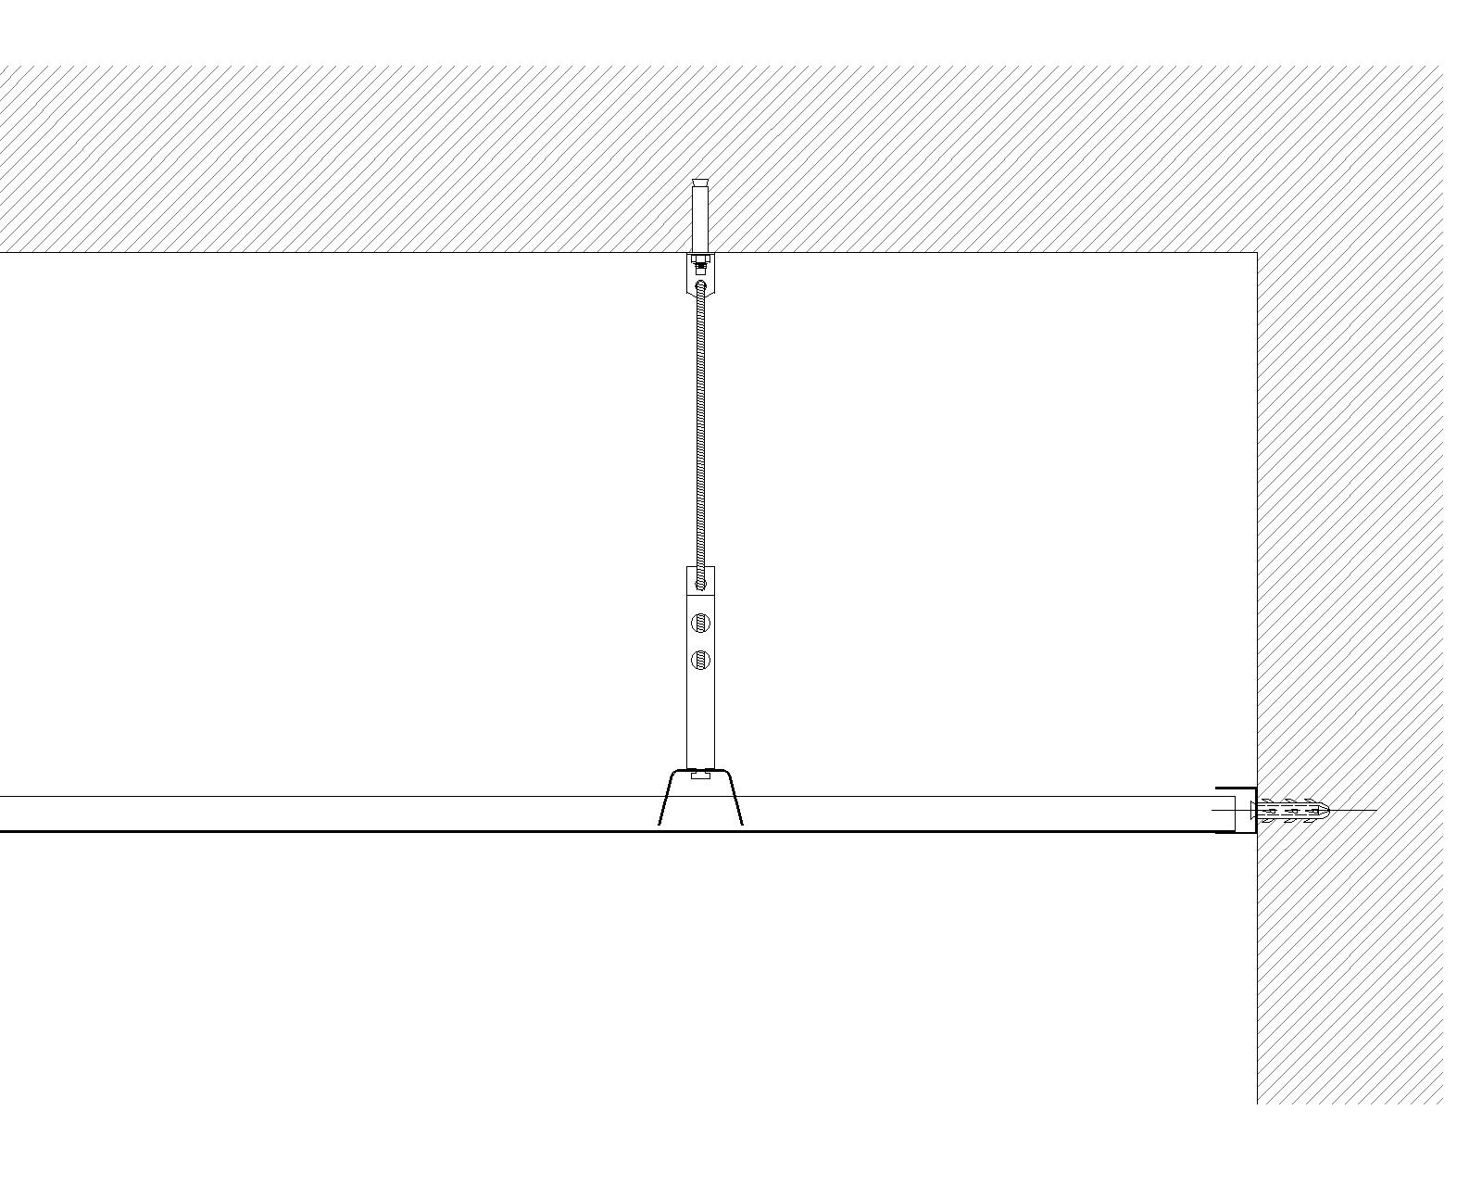
SECTION B
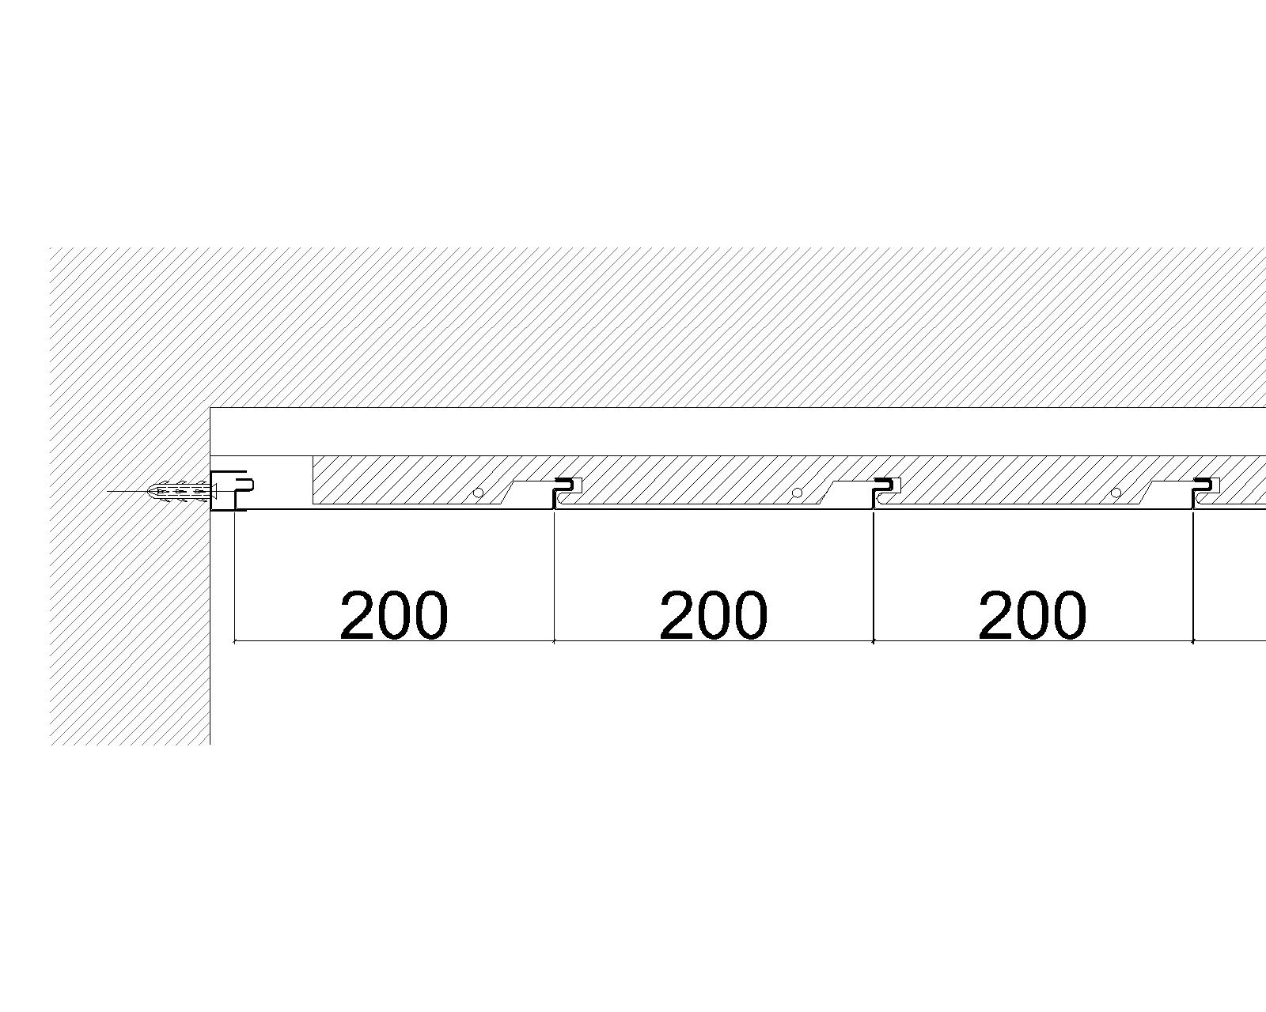
SECTION C(installing with steel box profile)
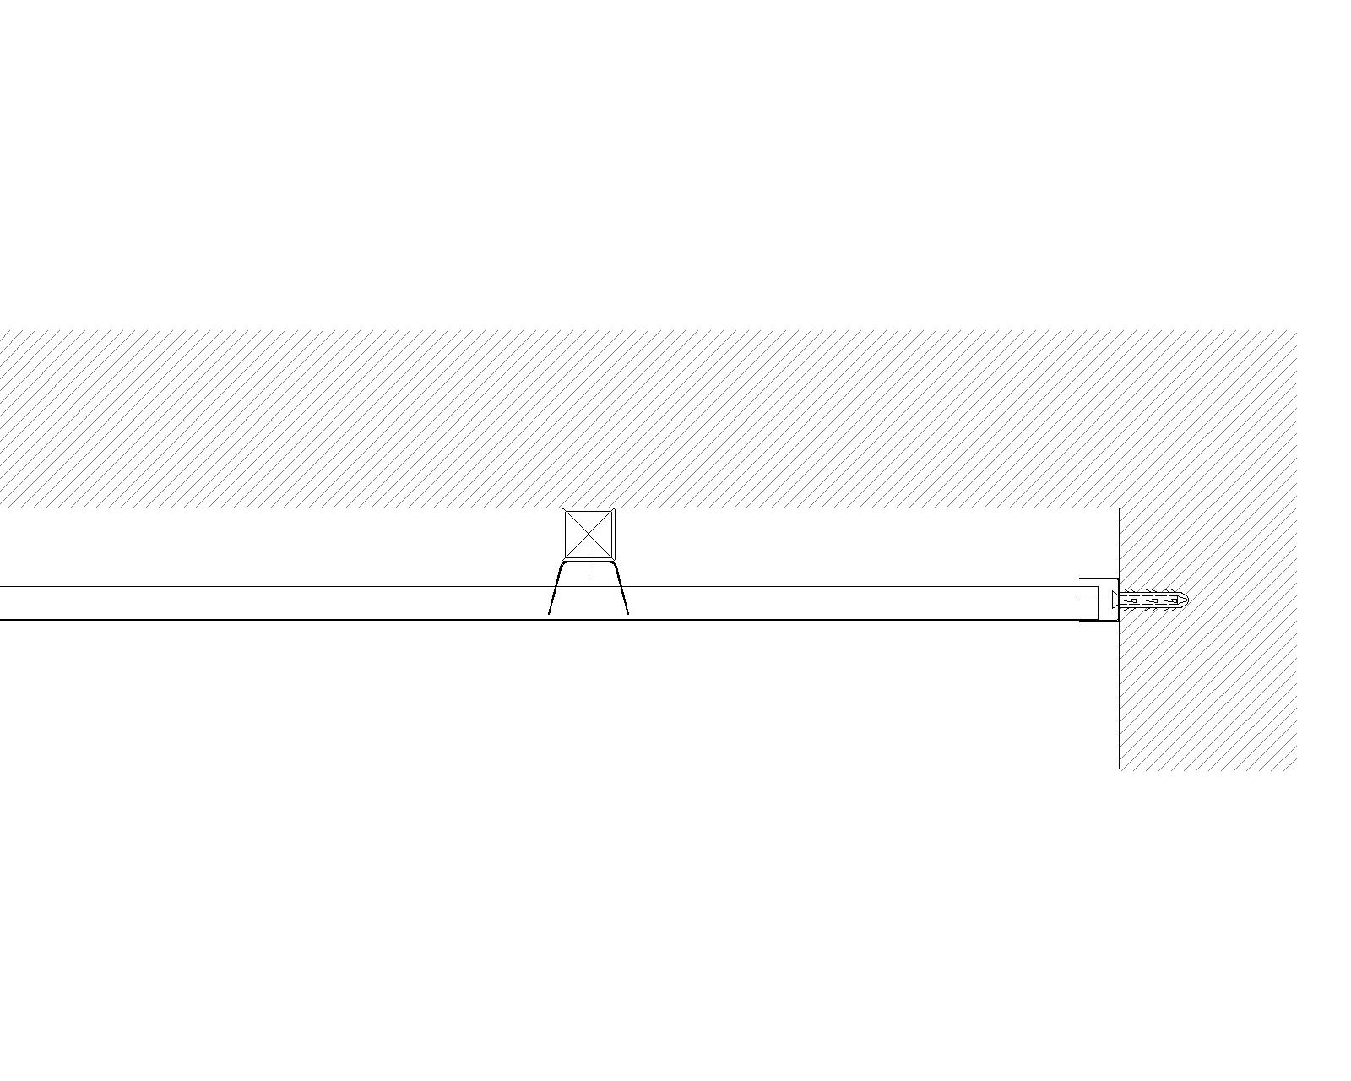
SECTION D(installing with steel box profile)

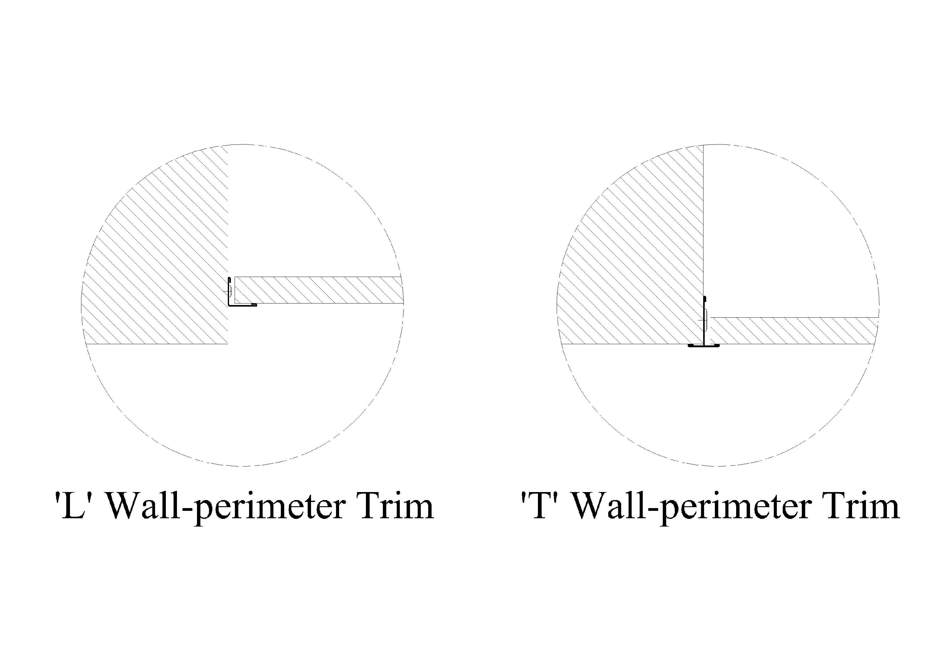
PERFORATIONS 