WOOD LINEAR SUSPENDED CEILING SYSTEM
DATASHEET

Technical Info:

Product : Wood Linear Suspended Ceiling System
Sizes : 18x100-120mm, lengths : according to shop drawing
Suspension System : T24 system made of main tee (24x38mm), galvanised steel
Specification:
c/c: 100mm center to center distance.

Drawing 1: Wood Linear Ceiling Plan
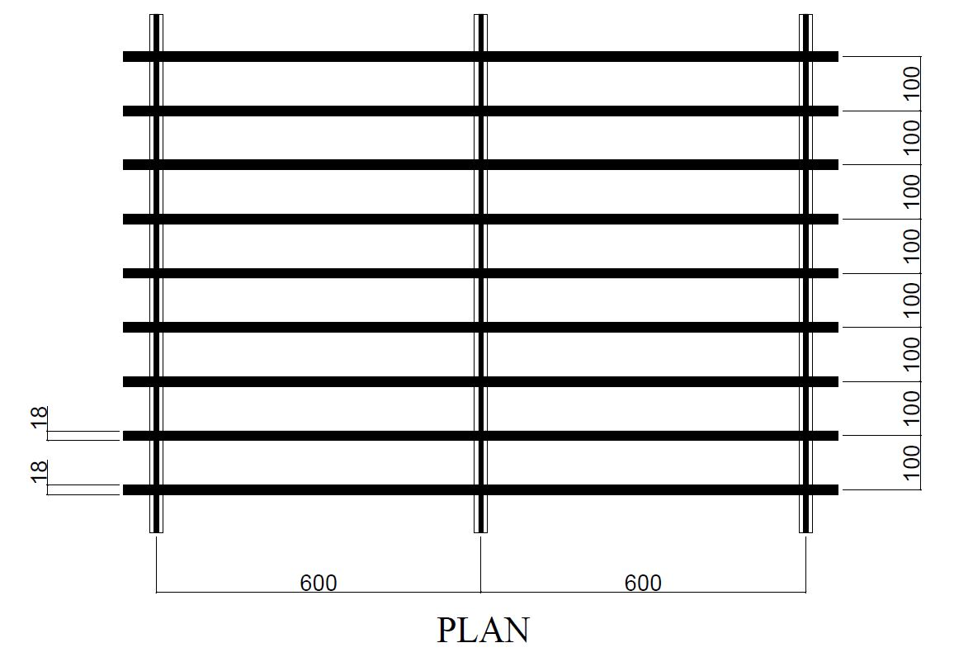

Drawing 2: Wood Linear Ceiling Section A
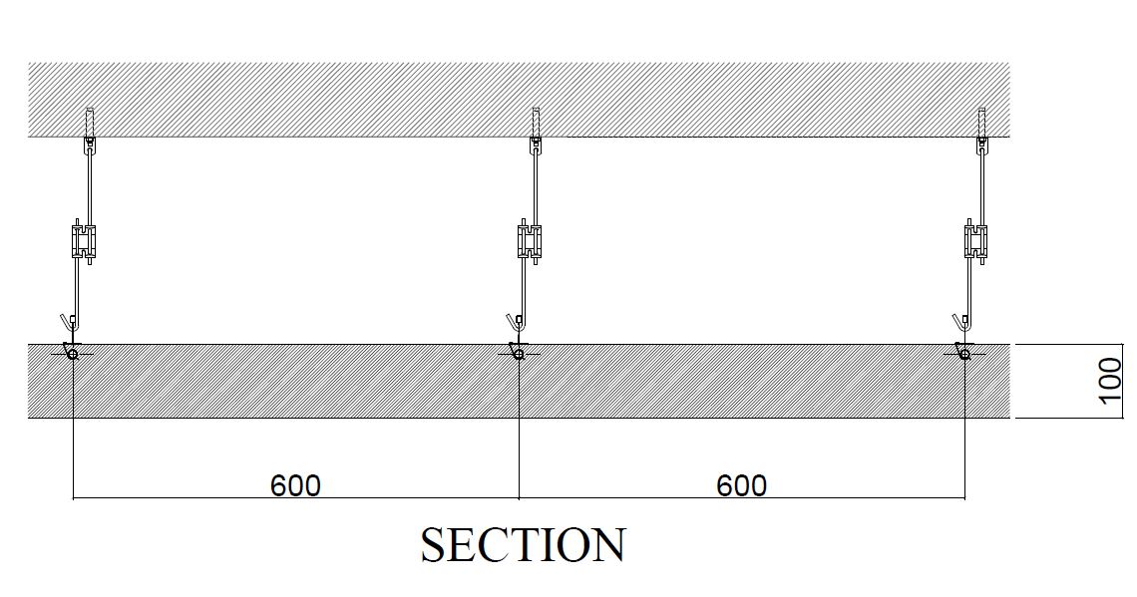

Drawing 3: Wood Linear Ceiling Section B
