DECKON PREMIUM METAL CEILINGS
CLIP-IN SYSTEM
DATASHEET

Technical Info:

Product : aluminium or galvanised steel
Sizes : 600x600mm, 300x600mm, 600x1200mm std
Thickness : 0.50 - 0.70 mm
Surface : electrostatic powder coated
Perforation : none or ∅1.8-2.5mm hole diameter with 10-50-100mm bordure
Suspension syst : hot dip galvanised steel, black
Edge detail : 20-30mm up-turns, as specified
Fire Resistance : class A as steel
Color : RAL 9016, standard white

Specification:
Standard clip-in system consists of a concealed supporting structure where demountable tiles can be clipped into the triangular omega main runner. The grid system is not visible. All panels are independently demountable thus enabling easy and fast access to the ceiling void.
VISUAL
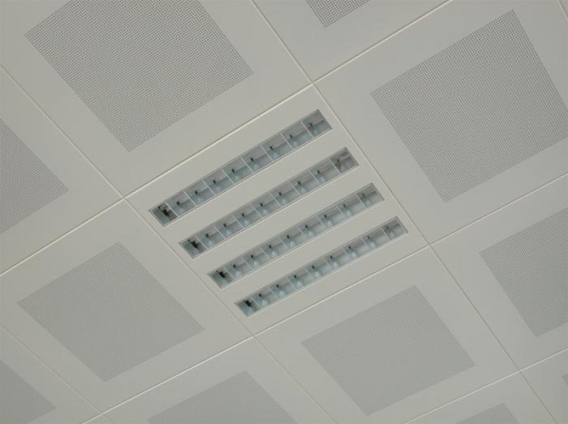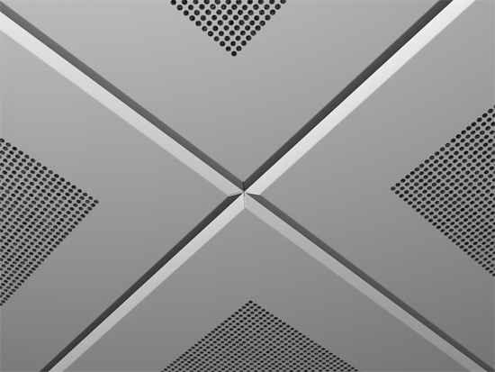
TECHNICAL DRAWINGS
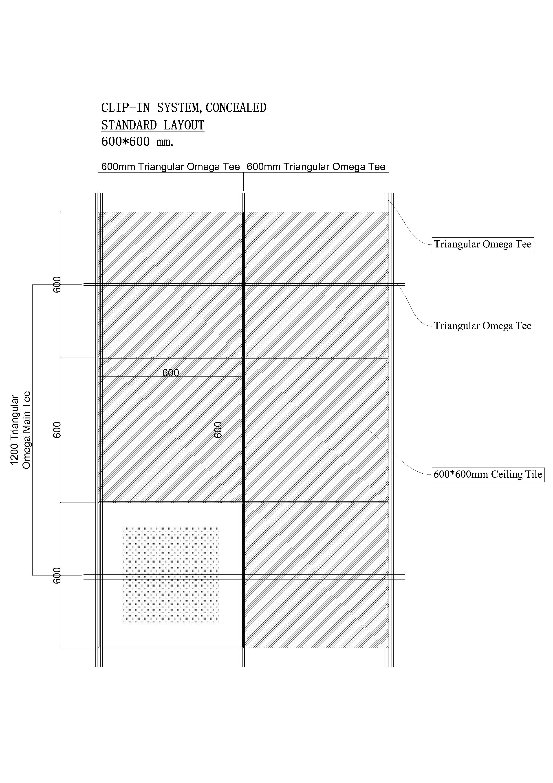
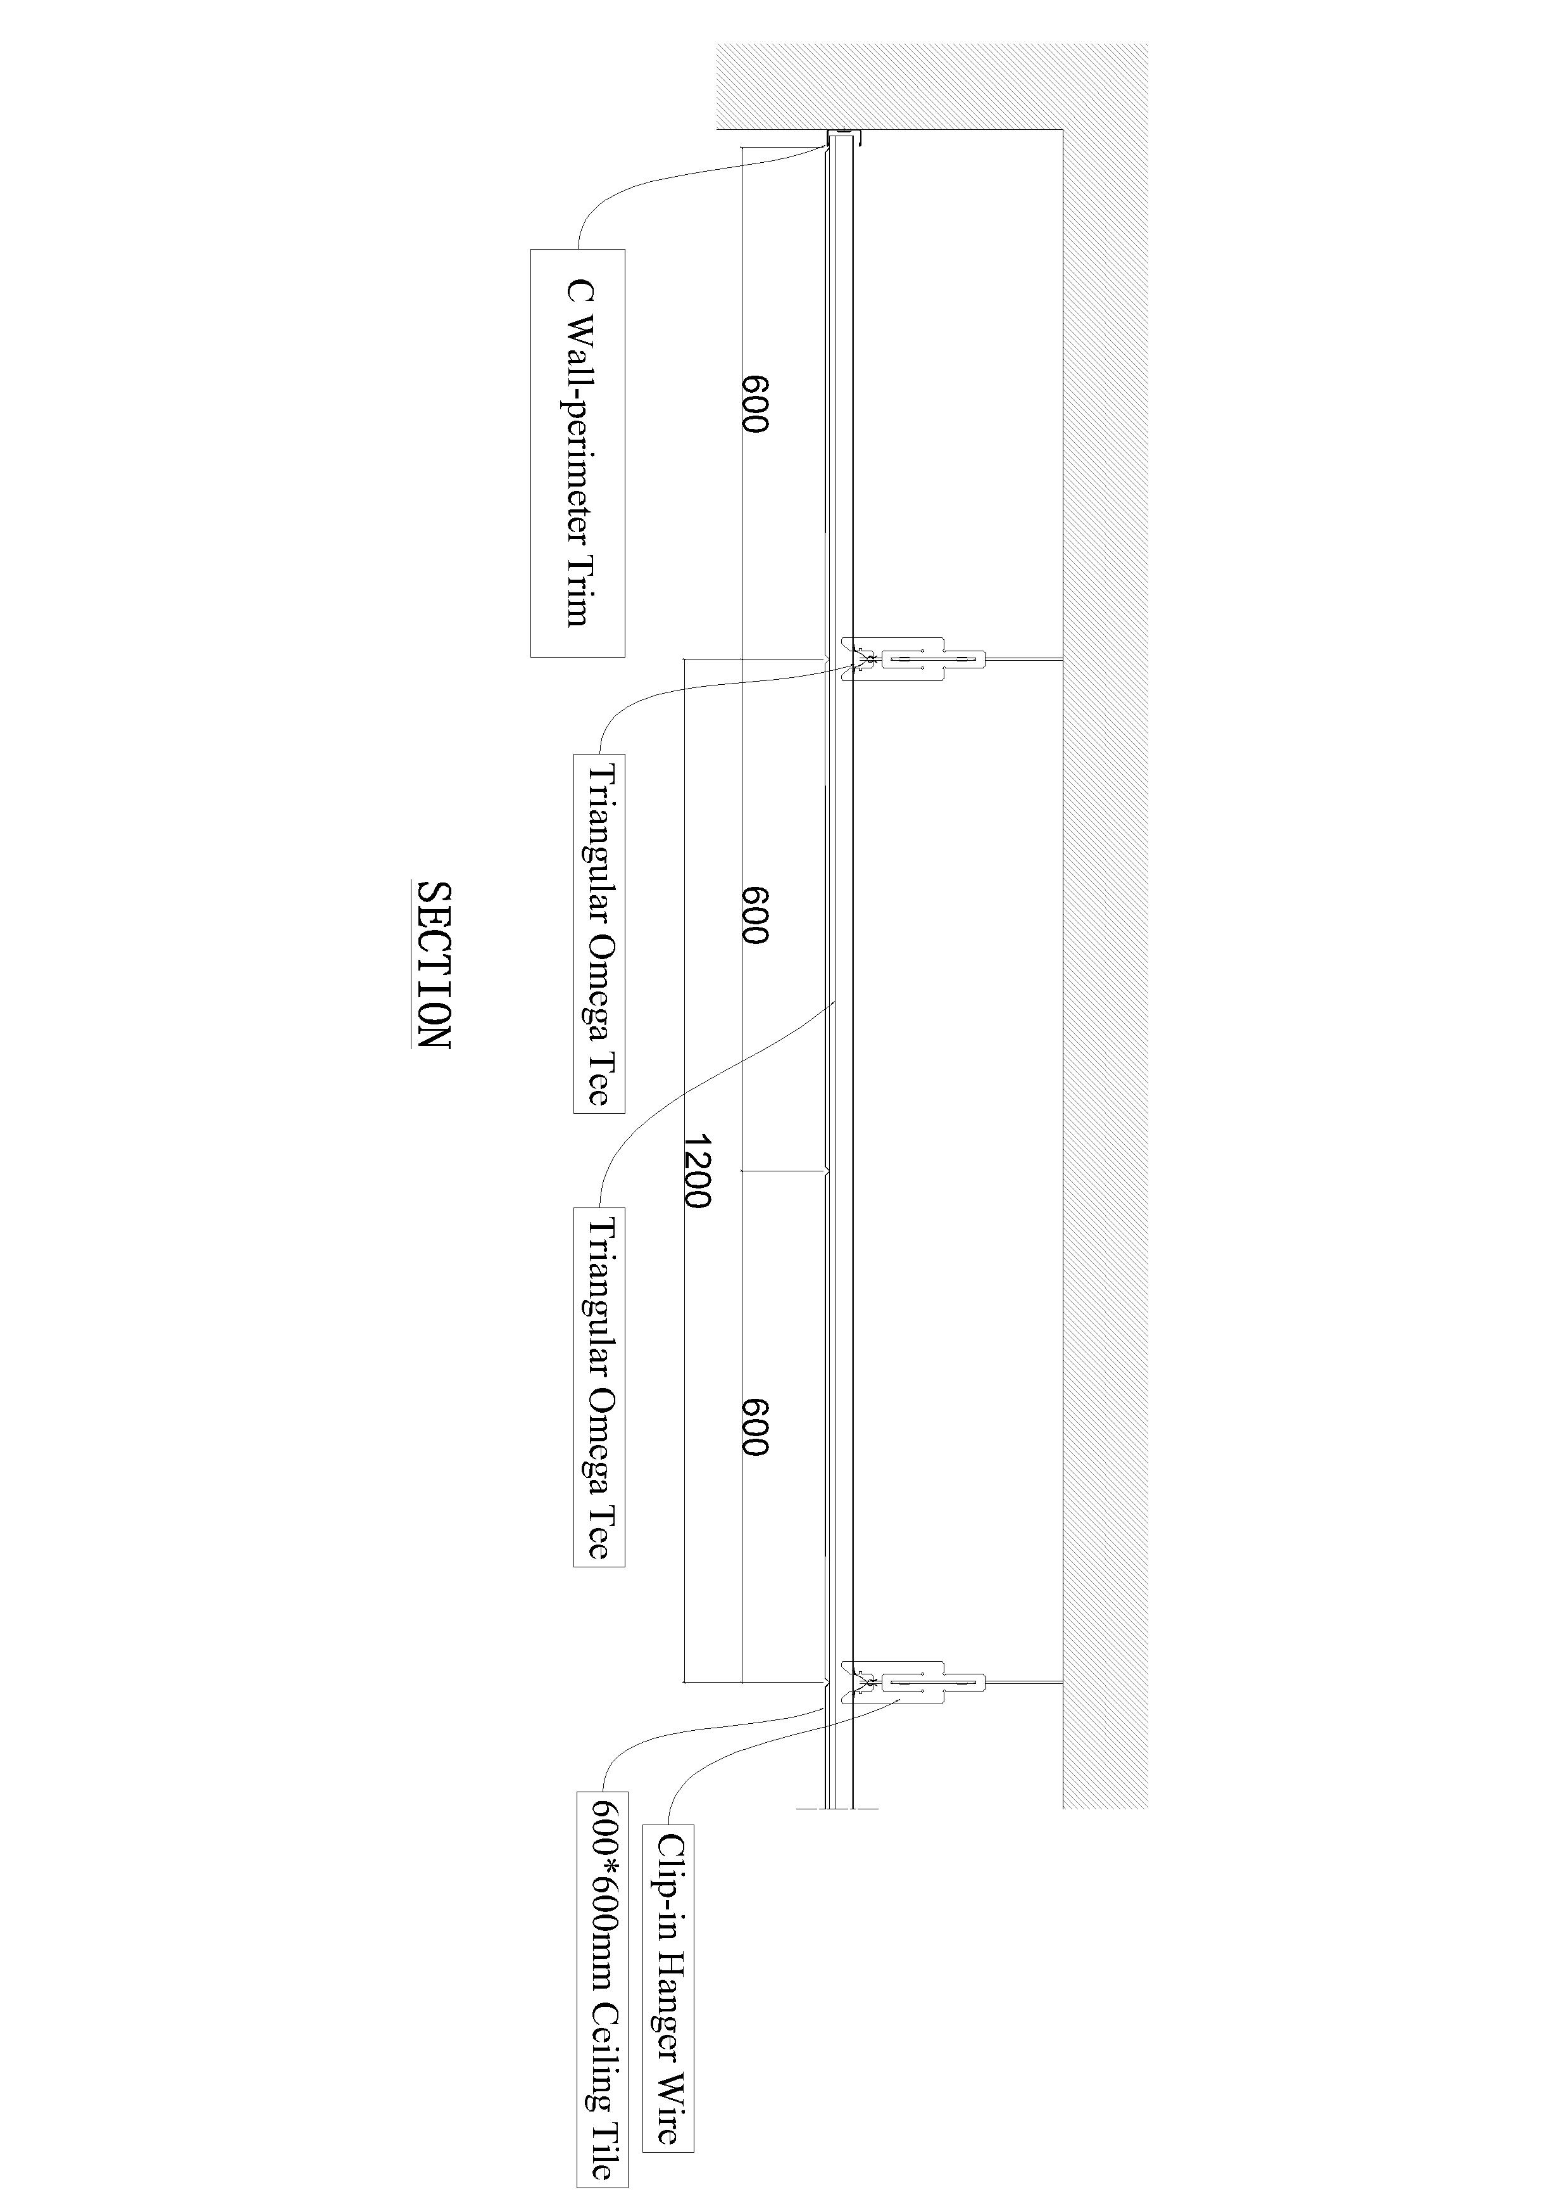
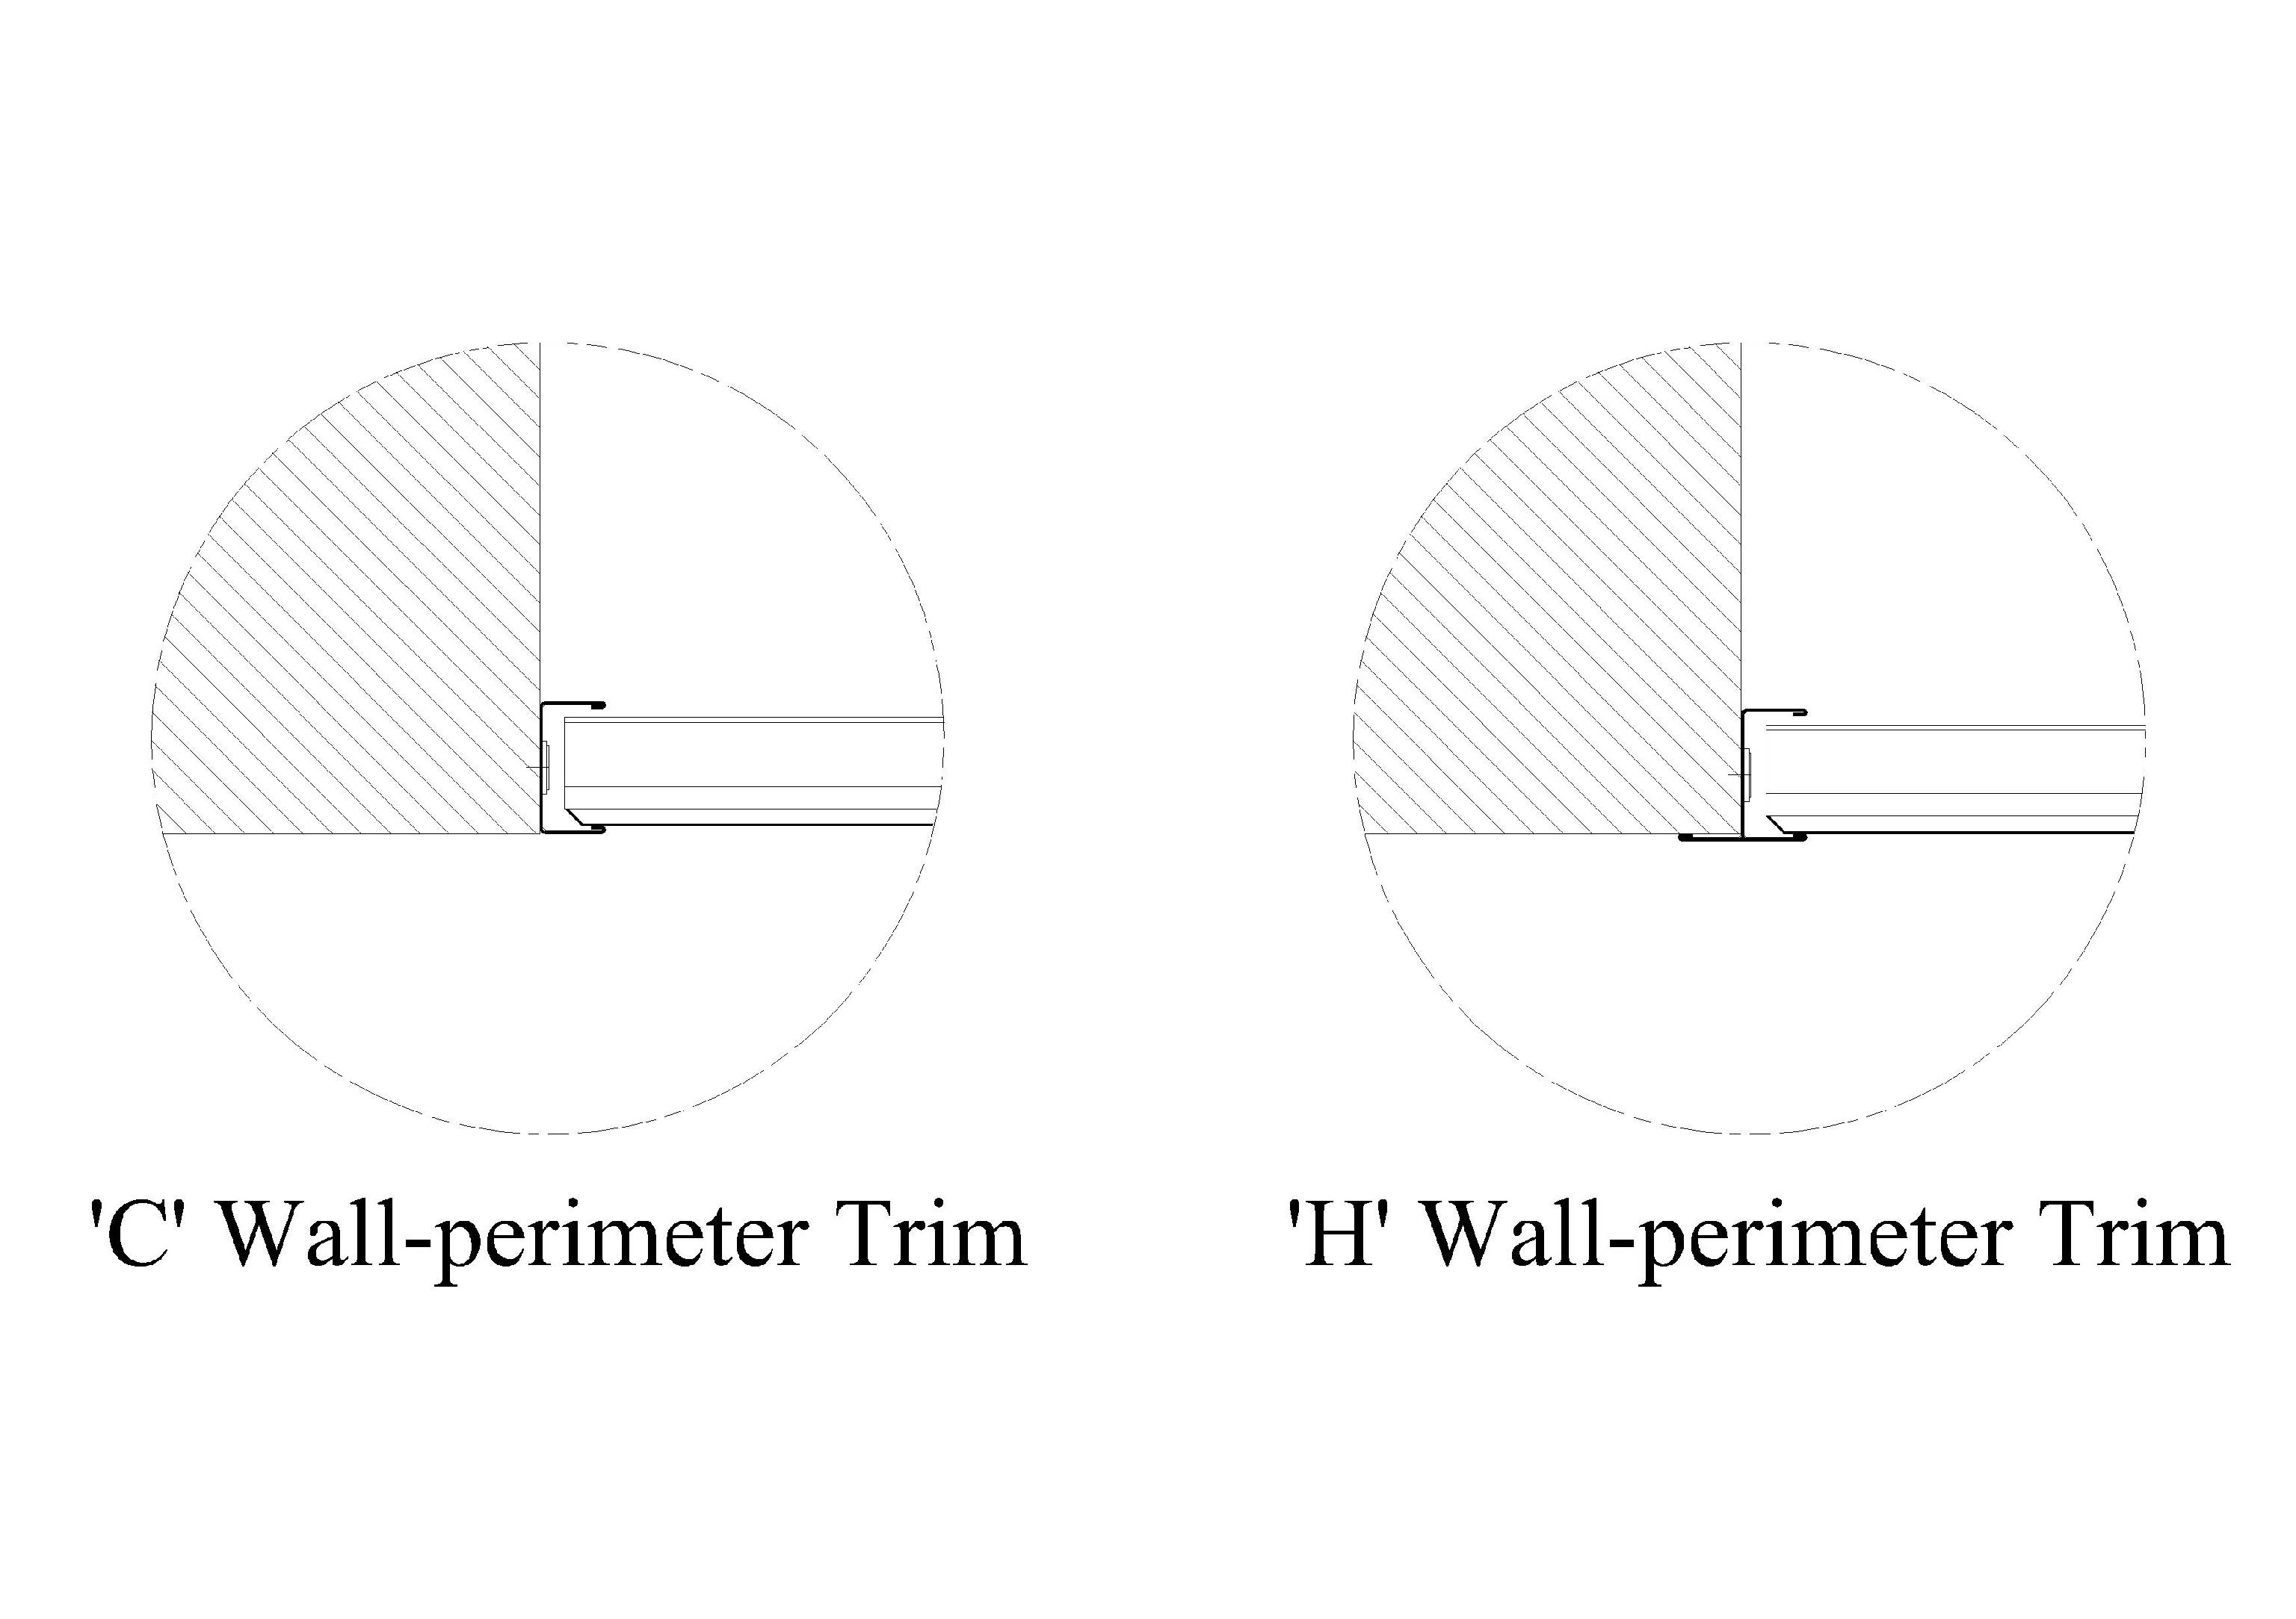
PERFORATIONS
